U.S. Consumer Product Safety Commission – Fast Track Recall with Health Canada

Release Date: February 3, 2021
Release Number: 21-Draft For Clearance3

Victory Innovations Recalls Electrostatic Sprayers with Lithium-ion Battery Packs Due to Fire and Explosion Hazards

Recall Summary

Name of Product: Victory Innovations and Protexus Electrostatic Sprayers

Hazard: The sprayer’s rechargeable lithium-ion battery pack can overheat and melt, posing a risk of the product catching fire and/or exploding.

Remedy: Replace
Consumers should immediately stop using the recalled sprayers, remove the battery pack and dispose it in accordance with local laws for disposal of lithium-ion batteries, and contact Victory Innovations for a free replacement battery pack, including shipping.
Consumer Contact: Victory Innovations toll-free at 888-674-2482 Monday to Friday from 8 a.m. to 5 p.m. ET, email at ES-Sprayerbatteryrecall@stericycle.com or online at www.victoryinnovations.com and click on Battery Recall for more information.
Recall Details

Units: About 405,000 (In addition, 27,000 in Canada)

Description: This recall involves Victory Innovations and Protexus-branded cordless handheld and backpack electrostatic sprayers used to disinfect surfaces. They come with a nozzle, nozzle wrench, tank, lithium-ion battery pack and a battery pack charger. The Victory Innovations cordless sprayers have a green and white exterior. The Victory Innovations logo appears on the front or the side of the green and white sprayers and model VP-20A or VP-20B appears on the battery pack. The Protexus logo appears on the front or the side of the black and white sprayers and model PX20A or PX20B appears on the battery back. Battery packs on recalled units have visible screw heads and a case with no parting lines.

Incidents/Injuries: Victory Innovations has received 37 reports of the lithium-ion battery pack in the electrostatic sprayers overheating, catching on fire or exploding, some of which resulted in property damage. No injuries have been reported.

Sold at: Chemical and cleaning supply distributors nationwide and online at Amazon.com, SupplyWorks.com (Home Depot Pro Institutional) and Staples.com from January 2016 through November 2020 for between $100 and $150.

Importer: Victory Innovations, of Twinsburg, Ohio
Manufactured in: China

Note:

Health Canada's press release is available at: https://healthycanadians.gc.ca/recall-alert-rappel-avis/index-eng.php?cat=4

Photos

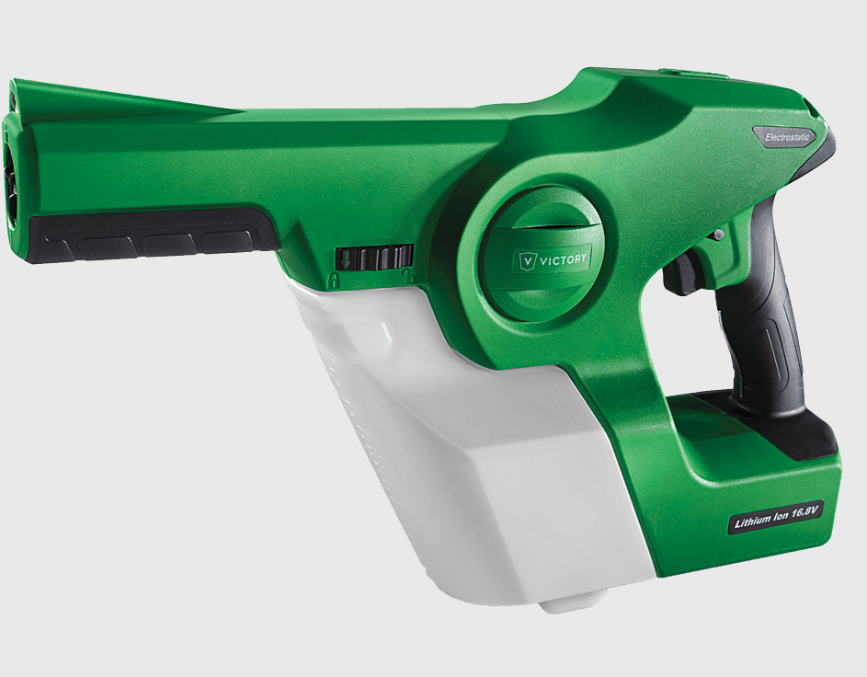
Recalled Victory Innovations cordless electrostatic sprayer–handheld

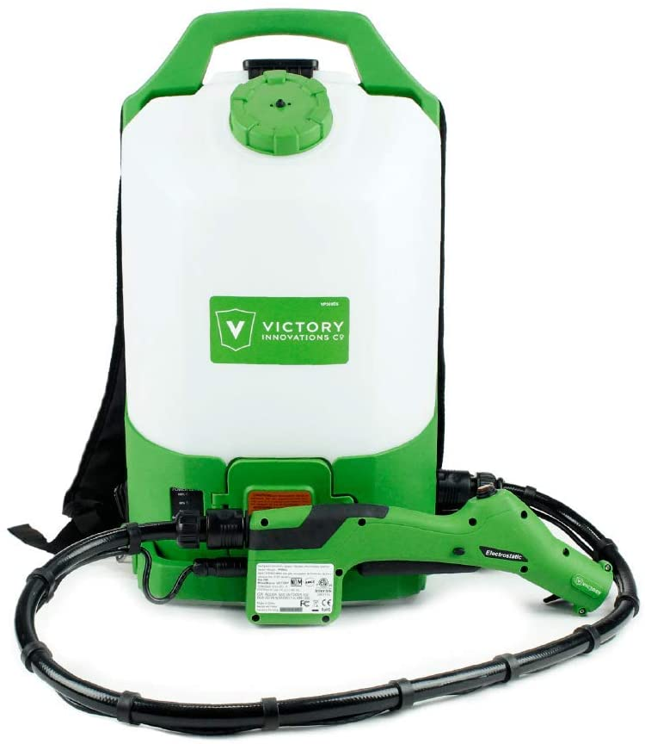

Recalled Victory Innovations backpack sprayer

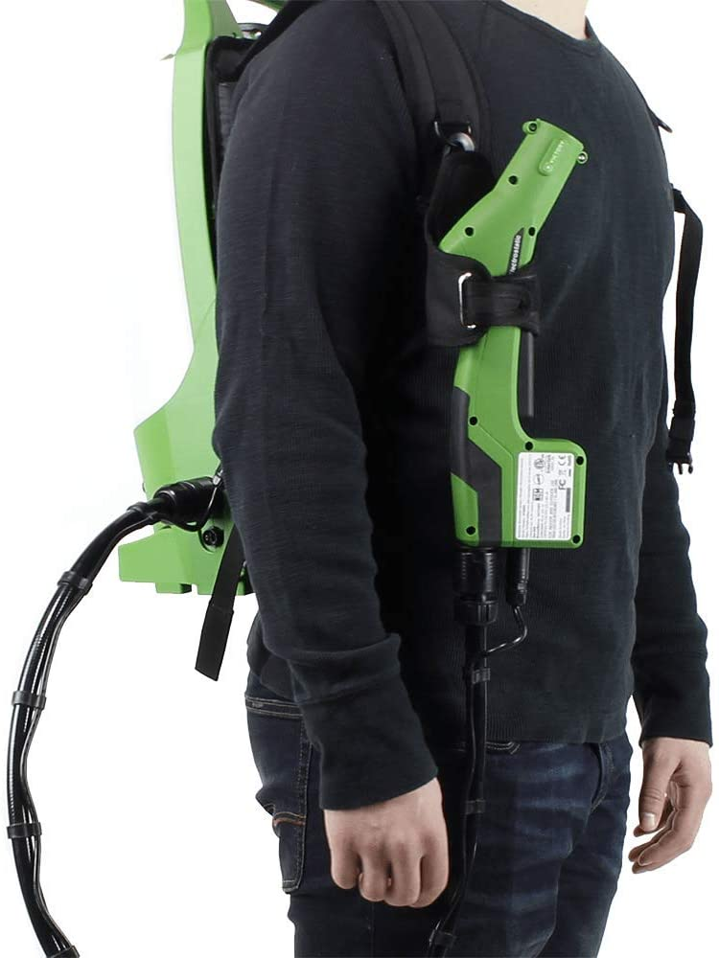

Recalled Victory Innovations backpack sprayer –equipped

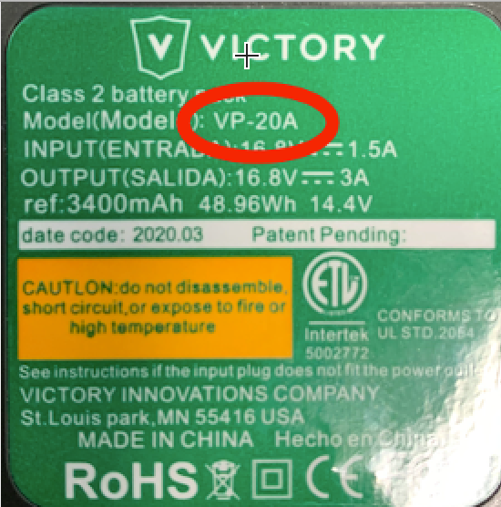

Model VP-20A or VP-20B is printed on the Victory Innovations’ battery pack’s label.

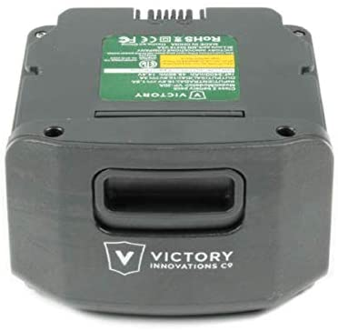

Victory Innovations sprayer’s lithium ion battery

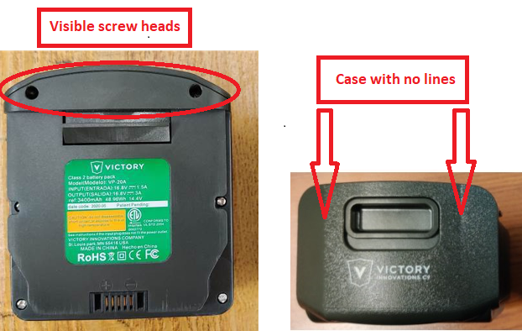

Battery packs on recalled units have visible screw heads and a case with no parting lines.

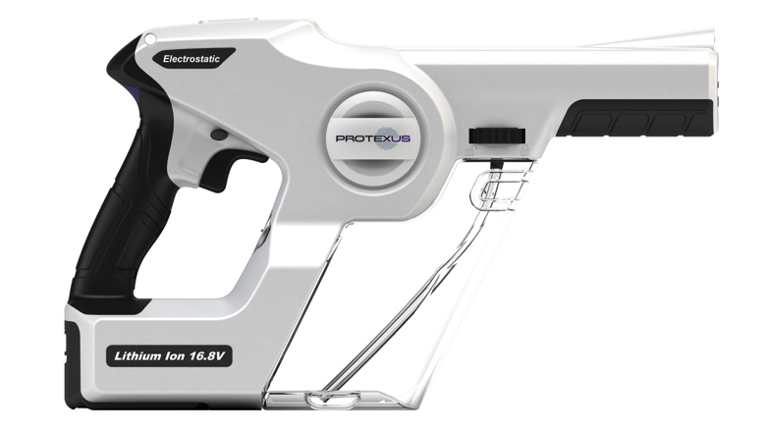
Recalled Protexus handheld sprayer

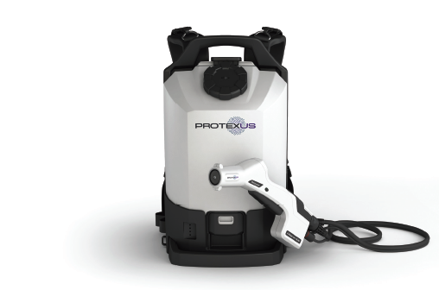
Recalled Protexus backpack sprayer
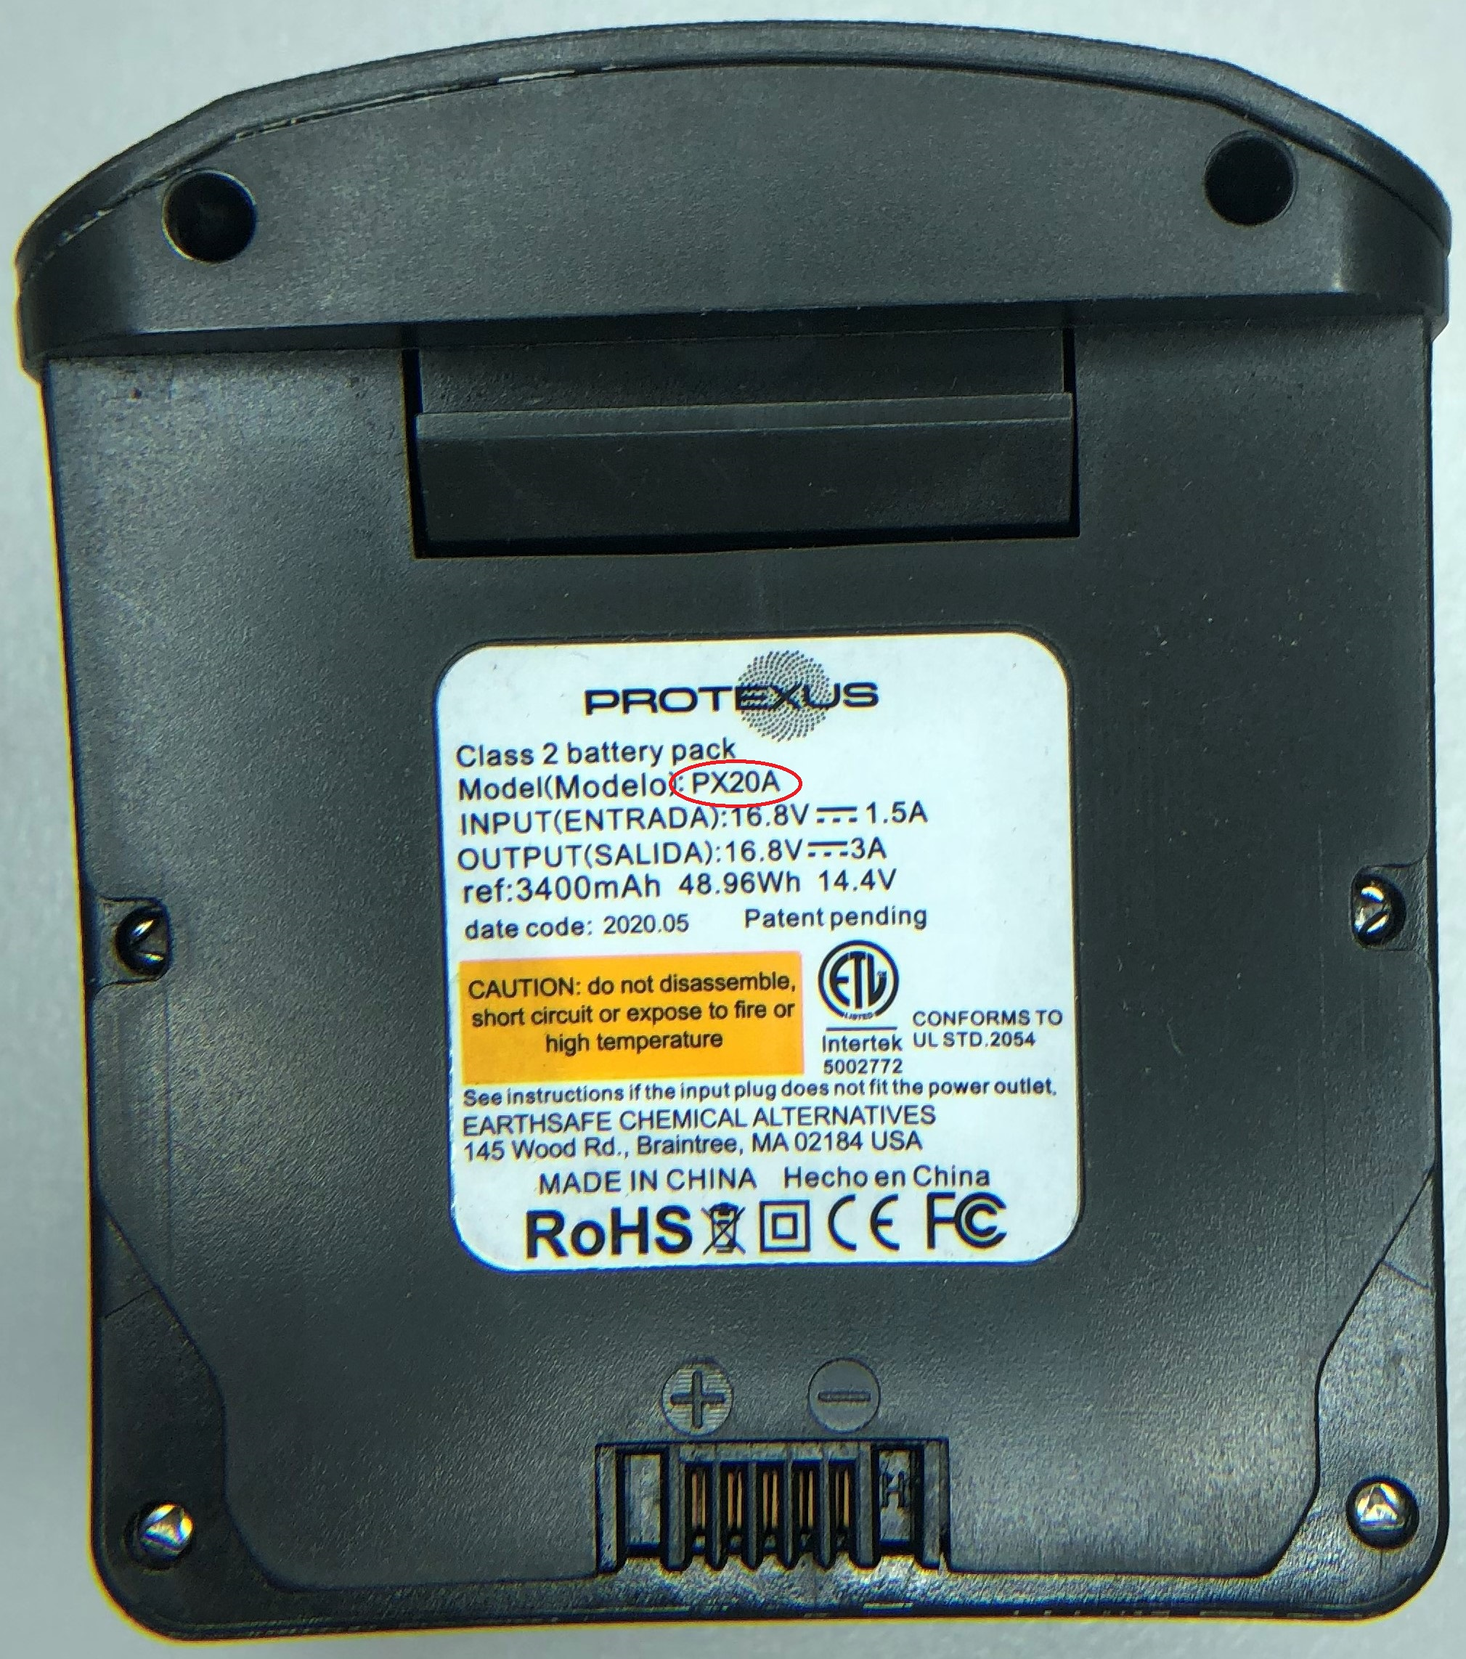
Model PX20A or PX20B is printed on the Protexus battery pack’s label.

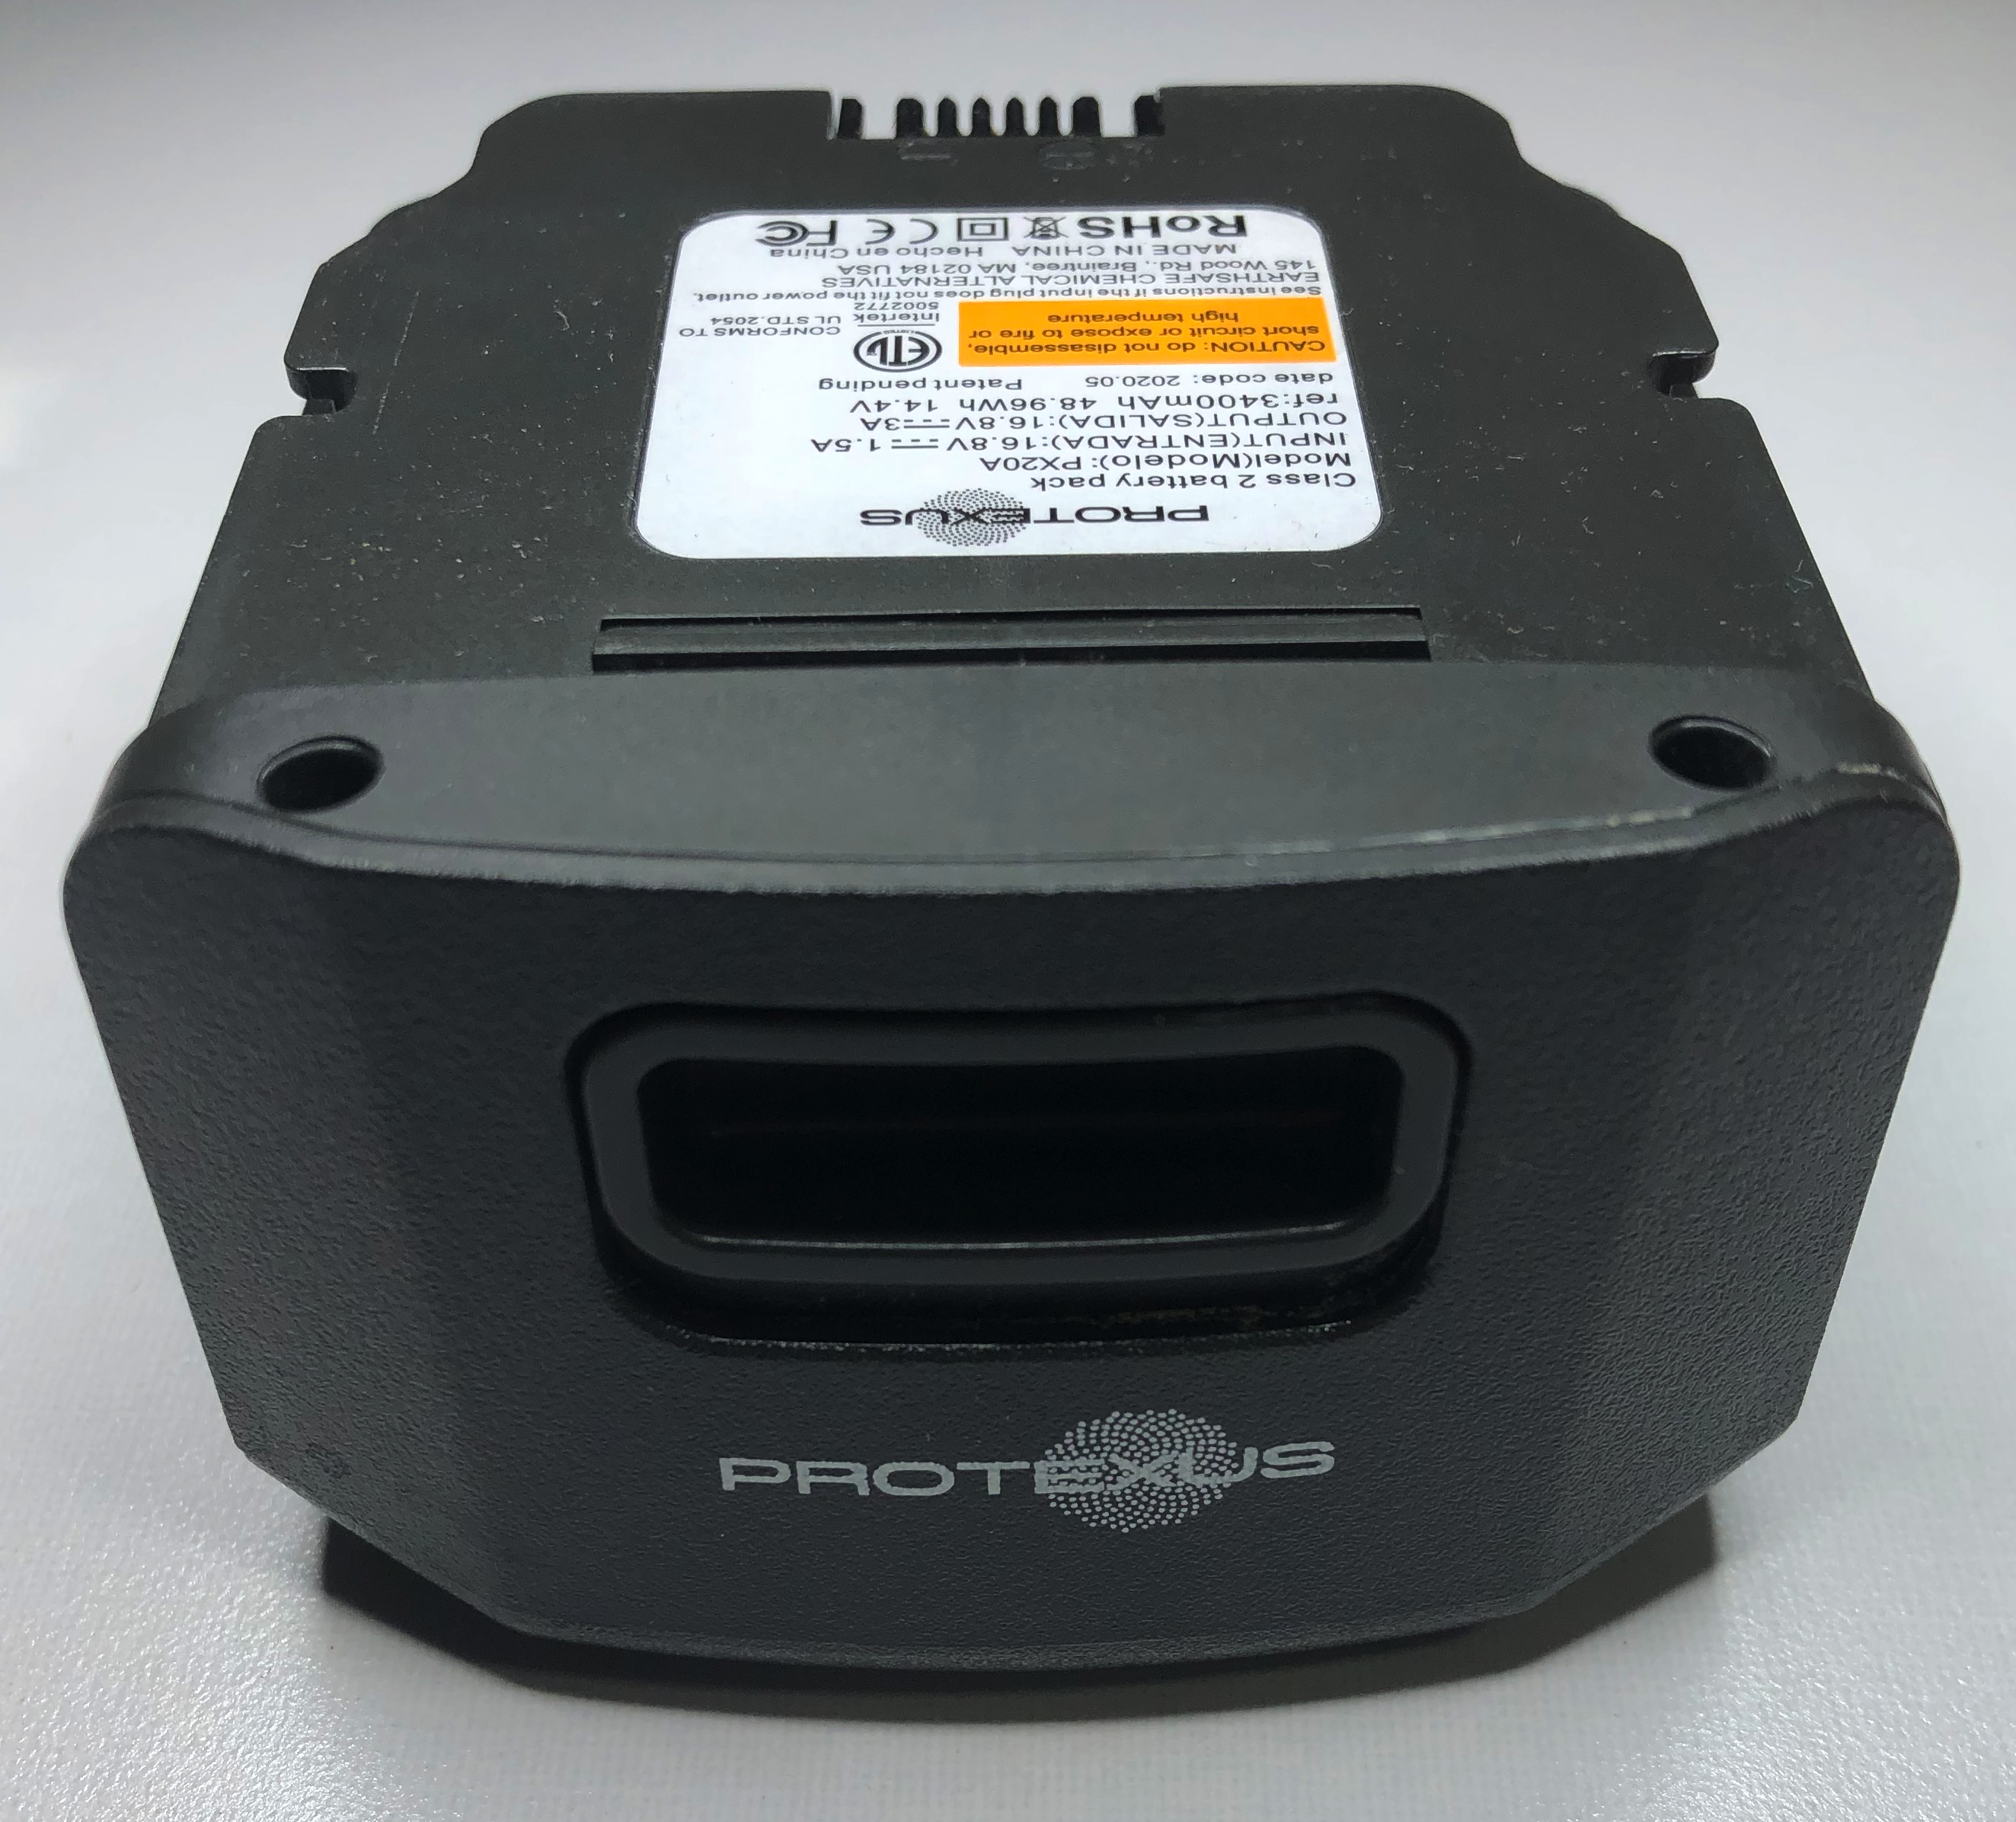

Protexus sprayer’s lithium ion battery

This recall was conducted voluntarily by the company under CPSC’s Fast Track Recall process. Fast Track recalls are initiated by firms who commit to work with CPSC to quickly announce the recall and remedy to protect consumers.

About the U.S. CPSC
The U.S. Consumer Product Safety Commission (CPSC) is charged with protecting the public from unreasonable risks of injury or death associated with the use of thousands of types of consumer products. Deaths, injuries, and property damage from consumer product incidents cost the nation more than $1 trillion annually. CPSC’s work to ensure the safety of consumer products has contributed to a decline in the rate of deaths and injuries associated with consumer products over the past 40 years.

Federal law bars any person from selling products subject to a publicly announced voluntary recall by a manufacturer or a mandatory recall ordered by the Commission.

For lifesaving information:
- Visit CPSC.gov.
- Sign up to receive our e-mail alerts.
- Follow us on Facebook, Instagram @USCPSC and Twitter @USCPSC.
- Report a dangerous product or a product-related injury on www.SaferProducts.gov.
- Call CPSC’s Hotline at 800-638-2772 (TTY 301-595-7054).
- Contact a media specialist.

